UNIT – V

MICROCONTROLLER PROGRAMMING & APPLICATIONS

***********************************************************************************************
Simple programming exercises-key board and display interface – Closed loop control of servo motor- stepper motor control – Washing Machine Control
**********************************************************************************

****************************************************************************************
Explain the interfacing of Keyboard with 8051. [June 2016.December 2016.April 2018]
************************************************************************************************

2.KEY BOARD AND DISPLAY INTERFACE

Keyboards are organized in a matrix of rows and columns
- The CPU accesses both rows and columns through ports. Therefore, with two 8-bit ports, an 8 x 8 matrix of keys can be connected to a microprocessor.
- When a key is pressed, a row and a column make a contact, Otherwise, there is no connection between rows and columns
- In IBM PC keyboards, a single microcontroller takes care of hardware and software interfacing.

A 4x4 matrix connected to two ports .The rows are connected to an output port and the columns are connected to an input port.
- It is the function of the microcontroller to scan the keyboard continuously to detect and identify the key pressed

- To detect a pressed key, the microcontroller grounds all rows by providing 0 to the output latch, then it reads the columns. If the data read from columns is D3 – D0 = 1111, no key has been pressed and the process continues till key press is detected.

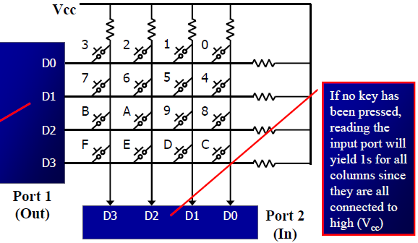

- If one of the column bits has a zero, this means that a key press has occurred, For example, if D3 – D0 = 1101, this means that a key in the D1 column has been pressed. After detecting a key press, microcontroller will go through the process of identifying the key.
- Starting with the top row, the microcontroller grounds it by providing a low to row D0 only.
- It reads the columns, if the data read is all 1s, no key in that row is activated and the process is moved to the next row.
- It grounds the next row, reads the columns, and checks for any zero
- This process continues until the row is identified
- After identification of the row in which the key has been pressed
- Find out which column the pressed key belongs to.

Program for detection and identification of key activation goes through the following stages:

- To make sure that the preceding key has been released, 0s are output to all rows at once, and the columns are read and checked repeatedly until all the columns are high.
- When all columns are found to be high, the program waits for a short amount of time before it goes to the next stage of waiting for a key to be pressed. To see if any key is pressed, the columns are scanned over and over in an infinite loop until one of them has a 0 on it.
- Remember that the output latches connected to rows still have their initial zeros making them grounded.

- After the key press detection, it waits 20 ms for the bounce and then scans the columns again.
- It ensures that the first key press detection was not an erroneous one due to a spike noise.
- If after the 20-ms delay the key is still pressed, it goes back into the loop to detect a real key press
- To detect which row key press belongs to,it grounds one row at a time, reading the columns each time
- If it finds that all columns are high, this means that the key press cannot belong to that row.Therefore, it grounds the next row and continues until it finds the row the key press belongs to.
- Upon finding the row that the key press belongs to, it sets up the starting address for the look-up table holding the scan codes (or ASCII) for that row.

- To identify the key press, it rotates the column bits, one bit at a time, into the carry flag and checks to see if it is low
- Upon finding the zero, it pulls out the ASCII code for that key from the look-up table
- otherwise, it increments the pointer to point to the next element of the look-up table
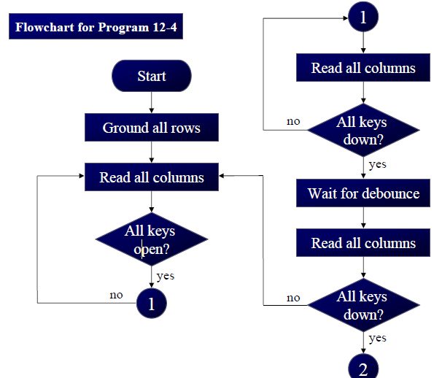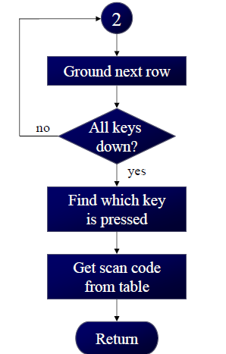

KEYBOARD INTERFACING WITH 8051:

The steps in algorithm are as follows:
- Initialize P1.0, P1.1, P1.2 and P1.3 as inputs.

- Check if all the keys are released by writing „0‟ to P1.4-P1.7 and check if all return lines are in state “1”. If not then wait.

- Call debounce.

- Wait for key closure. Ground all scan lines by writing „0‟ and then check if at least one of return lines shows „0‟ level.

- Call debounce.

- Is key really pressed? (Check at least one of the return lines shows „0‟ level). No Step 4 , Yes step 7.

- Find key code and display the key pressed on 7-segment display.

- Go to step 1.

PROGRAM:
From the above figure identify the row and column of the pressed key for each of the following.
  - D3 – D0 = 1110 for the row, D3 – D0 = 1011 for the column
  - D3 – D0 = 1101 for the row, D3 – D0 = 0111 for the column Solution:

From the above figure, the row and column can be used to identify the key.

- The row belongs to D0 and the column belongs to D2; therefore, key number 2 was pressed.
- The row belongs to D1 and the column belongs to D3; therefore, key number 7 was pressed.
; Keyboard subroutine.
; This program sends the ASCII code for pressed key to P0.1.
; P1.0 – P1.3 connected to rows P2.0 – P2.3 connected to columns.

LOOK-UP TABLE FOR EACH ASCII ROW ORG 300H
KCODE 0: DE ‘0’, ‘1’, ‘2’, ‘3’ ; Row 0
KCODE 1: DE ‘4’, ‘5’, ‘6’, ‘7’ ; Row 1
KCODE 2: DE ‘8’, ‘9’, ‘A’, ‘B’ ; Row 2
KCODE 3: DE ‘C’, ‘D’, ‘E’, ‘F’ ; Row 3

K1: | MOV P2, #0FFH MOV P1, #0 MCV A, P2  ANL A, #00001111B  CJNE A, #00001111B, K1 |  | ; make P2 an input port  ; ground all rows at once  ; read all column ensure all keys open.  ; masked unused bits  ; check till all keys released
K2: | ACALL DELAY |  | ; call 20 ms delay
 | MCV A, P2 |  | ; see if any key is pressed
 | ANL A, #00001111B |  | ; mask unused bits
 | CJNE A, #00001111B, OVER |  | ; key pressed, await closure
 | SJMP K2 |  | ; check if key pressed
OVER: | ACALL DELAY |  | ; wait 20 ms debounce time
 | MCV A, P2 |  | ; check key closure
 | ANL A, #00001111B |  | ;
 | CJNE A, #00001111B, OVER1 |  | ;
 | SJMP K2 |  | ;
OVER1: MOV P1, #11111110B |  |  | ;
 | MOV A, P2 |  | ;
 | ANL A, #00001111B |  | ;
CJNE A, #00001111B, ROW_0
MOV P1, #11111101B
MOV A, P2
ANL A, #00001111B
CJNE A, #00001111B, ROW_1
MOV P1, #11111011B
MOV A, P2
ANL A, #00001111B
CJNE A, #00001111B, ROW_2
MOV P1, #11110111B
MOV A, P2
ANL A, #00001111B
CJNE A, #00001111B, ROW_3
LJMP F2
MOV DPTR, #KCODE 0
SJMP FIND
MOV DPTR, #KCODE 1
SJMP FIND
MOV DPTR, #KCODE 2
SJMP FIND
MOV DPTR, #KCODE 3
RRC A
JNC MATCH
INC DPTR
MATCH: SJMP FIND
CLR A
MOVC A, @A + DPTR
MOV P0, A
LJMP K1

The steps in algorithm are as follows:
- Initialize P1.0, P1.1, P1.2 and P1.3 as inputs.

- Check if all the keys are released by writing „0‟ to P1.4-P1.7 and check if all return lines are in state ‘1’. If not then wait.

- Call debounce.

- Wait for key closure. Ground all scan lines by writing „0‟ and then check if at least one of return lines shows „0‟ level.
- Call debounce.

***************************************************************************************
Explain the interfacing of stepper motor with 8051. [June 2016/April 2018][DEC 2018]

***************************************************************************************

3. Interfacing stepper motor with 8051

STEPPER MOTOR
A stepper motor is a brushless, synchronous electric motor that converts digital pulses into mechanical shaft rotation. Every revolution of the stepper motor is divided into a discrete number of steps, and the motor must be sent a separate pulse for each step.
Stepper motors can be used in various areas of your microcontroller projects such as making robots, robotic arm, and automatic door lock system.
Fig. shows how to interface the Stepper Motor to microcontroller. As you can see the stepper motor is connected with Microcontroller output port pins through a ULN2803A array. So when the microcontroller is giving pulses with particular frequency to ls293A, the motor is rotated in clockwise or anticlockwise.
Step Angle

- Step angle of the stepper motor is defined as the angle traversed by the motor in one step.
- To calculate step angle, simply divide 360 by number of steps a motor takes to complete one revolution.
- Motor rotating in full mode takes 4 steps to complete a revolution ,so step angle can be calculated as step angle θ = 360° / 4 =90.
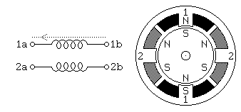
- By knowing the stepper motor step angle helps to move the motor in correct angular position.
- As you can see the stepper motor is connected with Microcontroller output port pins through a ULN2803A array.
- So when the microcontroller is giving pulses with particular frequency to ls293A, the motor is rotated in clockwise or anticlockwise
Program to interface Stepper motor with 8051
- To control a stepper motor in 8051 trainer by turning ON & OFF a four I/O port lines generating at a particular frequency.
- The 8051 trainer kit has three numbers of I/O port connectors, connected with I/O Port lines (P1.0 – P1.7), (P3.0 – P3.7) to rotate the stepper motor.
- 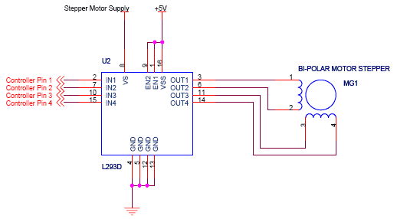LS293D is used as a driver for port I/O lines, drivers output connected to stepper motor, connector provided for external power supply if needed.

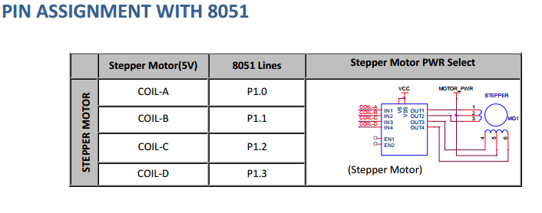
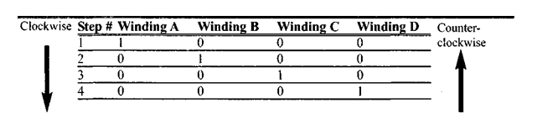
By giving the excitation as indicated above through port 1 we can rotate stepper motor in clockwise or anticlockwise direction.
NOTE: To turn the motor in the reverse direction enter as (RL A instead of RR A). The schematic sections given is, stepper motor connected to port 1 and the sample program is given based on 8255.

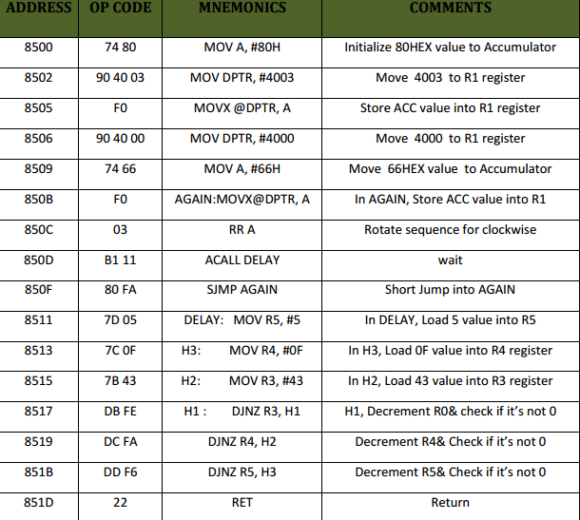

Example 4: Describe the 8051 connection to the stepper motor of figure shows and code a program to rotate it continuously.
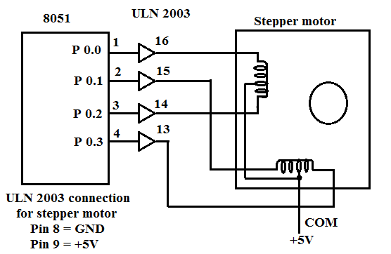
Figure : Interfacing Stepper Motor with 8051
Solution:

 | MOV | A, #66H | Load step sequence
BACK: | MOV | P1, A | Issue sequence to  motor
 | RR | A | Rotate right  clockwise
 | ACALL | DELAY | Wait
 | SJMP | BACK | Keep going
 | …………….
DELAY
 | MOV | R2, #100H
H1: | MOV | R3, #255H | H1:
H2: | DJNZ | R3, H2 | H2:
 | DJNZ | R2, H1
 | RET

********************************************************************************************
Describe with a neat diagram, the washing machine control using 8051 microcontroller. [April/May 2015]
Explain the working of a washing machine and how it is controlled by the 8051 controller. [Nov/Dec 2015, May/June 2014, Nov/Dec 2014, Dec 2016]
**********************************************************************************************
4. WASHING MACHINE CONTROL
INTRODUCTION:
  - Washing machine consists of a washing basket that can rotate.
  - In the centre of the basket is a cylindrical vertical column called Agitator.
  - The Agitator can also move independently.
  - The water, detergent and cloths are put in the washing basket.
  - During washing, the agitator and the washing basket rotate in opposite directions in small steps.
  - Due to this action, the clothes get washed.

Input Settings
There are four knobs for programming the washing machine.

Load select
    - Load means the number of clothes intended to be washed together.
    - There are three settings (high, medium and low).
    - Based on the load selected, the machine decides the amount of water required.

Water Inlet Select
    - Machine can take either hot, tap or mix water.
    - There are two inlet pipes on the machine for hot and tap water.
    - The knob setting “mix” allows 50% tap and 50% hot water as input.

Modes
Through this knob, the machine can be operated normal or save mode.

Normal mode
  - The clothes are washed.
  - The detergent is drained.
  - The fresh water is put.
  - The clothes are rinsed.
  - The water is drained.
  - Using spin, the moisture from clothes is taken out.

Save mode
The save mode has been designed to save detergent, and is used when clothes need to be washed in a number of lots.

Program Select
    - Using this knob, the machine is programmed to wash the clothes of different kinds.
    - The various settings are Extra Heavy, Heavy, Normal, Light and Delicate.

Indications
- Machine ON: There is an LED indication which glows when the machine is ON.
- Washing Complete: A sound is generated to announce that the washing is complete.

Washing Cycle
Different operations performed by the machine in a typical wash cycles are

Fill
  - Agitate
  - Soak
  - Drain
  - Spin
- Fill:
  - Water is filled through the inlet.
  - The quantity of water depends on the load setting (high, medium or low).
  - In the first fill, water temperature is decided by the setting tap, hot or mix.
  - In the second fill, after drain and spin, only tap water is filled for rising the clothes.

Agitate:
  - In this operation, the wash basket rotates in small steps.
  - After every step, it waits for some second.
  - Simultaneously, the agitator rotates in the opposite direction in small steps and after every step, there is wait state.

Soak:
  - The operation is used to allow the clothes to soak the detergent.
  - The machine operation basically stops for a specified time period.

Drain:
  - All the water and detergent are taken out through the drain pipe.

Spin:
  - In this operation, the agitator does not move.
  - The wash basket is rotated at high speed and most of the moisture from clothes is taken out through holes in the inner metallic basket.

Control System Design
- With the above knowledge about the operation of the washing machine, consider 8051 microcontroller based washing machine.

The various controls are:
- Inlet control of water
- Water quantity control
- Agitator control
- Spin control
- Drain control
- Program control
- Water inlet select
- Load select

Inputs & Output port assignments:

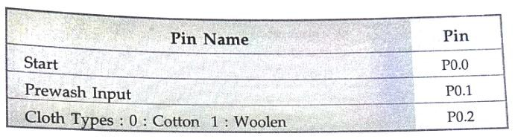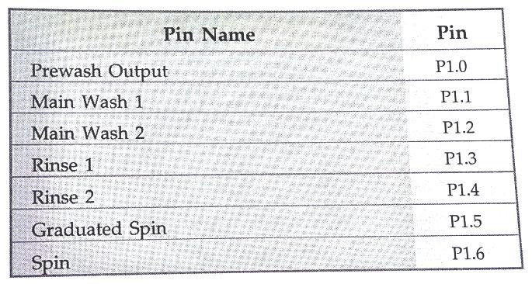

FLOW CHART FOR WASHING MACHINE:

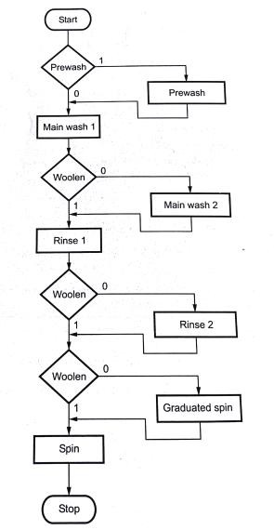

WASHING MACHINE INTERFACING USING 8051
The various indications are:
  - Machine on indication (LED)
  - Washing complete (LED + BUZZER)
- All the ports of 8051 can be used for input – output operations.
- Agitator control requires controlling of both stepper motors 1 and 2.
- Hence eight lines will be required for this purpose.

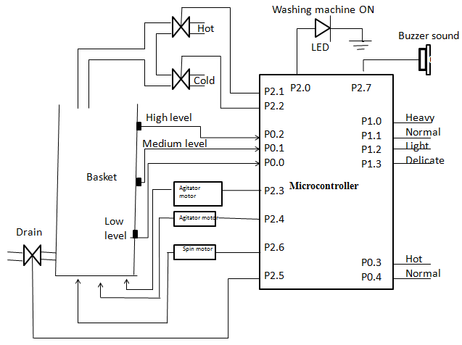

Figure: Washing Machine control Circuit using 8051

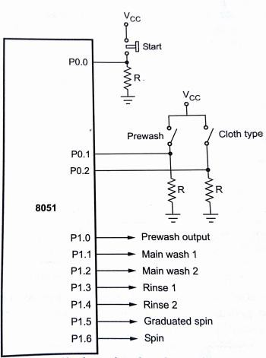
Figure: Hardware interfacing using 8051

PROGRAM:
SMRT: JNB P0.0, START ; check for star
JNB P0.1, SKIPW ; check if prewash is activated
SETB P1.0 ; if yes do prewash CALL D_PREWASH
; wait for prewash
CLRB P1.0 ; stop prewash

SKIPW: SETB P1.1 ; Do Main wash 1

CALL D_MAINWASH1 ; Wait for main wash 1

CLRB P1.1 ; stop main wash 1
JNB P0.2, SKIPMW2 ; check if cloth type is cotton
SETB P1.2 ; if yes do main wash
CALL D_MAINWASH2 ; Wait for main wash2
CLRB P1.2 ; stop main wash 2

SKIPMW2: SETB P1.3 ; Do rinse 1
CALL D_RINSE1 ; wait for rinse 1
CLRB P1.3 ; stop rinse 1
JNB P0.2, SKIPRINSE2 ; Check for cloth type is cotton
SETB P1.4 ; If yes do rinse 2
CALL D_RINSE2 ; Wait for rinse 2
CLRB P1.4 ; stop rinse 2
JNB P0.2, SKIPGS ; check for cloth type is cotton
SETB P1.5 ; If yes do gradual spin
CALL D_GS ; wait for gradual spin
CLRB P1.5 ; stop gradual spin

SKIPGS: SETB P1.6 ; Do spin
CALL D_SPIN ; wait for spin
CLRB P1.6 ; Stop Spin
LJMP START ; Go to start
**************************************************************************************************
Explain the closed loop control of a servo motor using 8051 with a neat diagram.[April/May 2017, May/June 2016, Nov/Dec 2014, May/June 2013,Nov/Dec 2015][December2017]
Explain the servo motor using 8051 microcontroller. [April/May 2011]
***************************************************************************************
- CLOSED LOOP CONTROL OF SERVO MOTOR

INTRODUCTION:
  - Servo motor is based on servo mechanism and it is mainly used for position control.
  - A servo system mainly consists of three basic components –

A controlled device

    - Output sensor

    - Feedback system.

  - This is an automatic closed loop control system.

  - Here instead of controlling a device by applying the variable input signal, the device is controlled by a feedback signal generated by comparing output signal and reference input signal

The servo motor is most commonly used in the industrial application like automation technology.

  - It is a self contained electrical device that rotates parts of a machine with high efficiency and great precision.
  - The output shaft of this motor can be moved to a particular angle.

  - Servo motors are mainly used in home electronics, toys, cars, airplanes, etc

TYPES OF SERVO MOTOR:

  - Servo motors are classified into different types based on their application, such as

AC servo motor
    - DC servo motor
    - Brushless DC servo motor
    - Positional rotation
    - Continuous rotation

Linear servo motor etc.

  - Typical servo motors comprise of three wires namely, power control and ground.
  - The shape and size of these motors depend on their applications. DC SERVO MOTOR.
  - The motor which is used as a DC servo motor generally have a separate DC source in the field of
winding & armature winding.
  - DC servo motor provides very accurate and also fast respond to start or stop command signals due to the low armature inductive reactance.
  - DC servo motors are used in similar equipments and computerized numerically controlled machines.

AC SERVO MOTOR:

  - AC servo motor is an AC motor that includes encoder is used with controllers for giving closed loop control and feedback.
  - This motor can be placed to high accuracy and also controlled precisely as compulsory for the applications.
  - Applications of an AC motor mainly involve in automation, robotics, CNC machinery, and other applications a high level of precision and needful versatility.
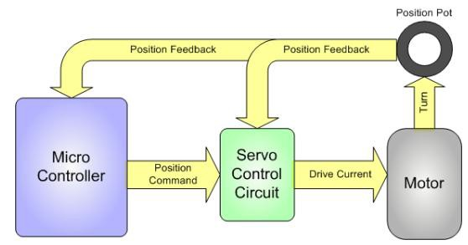

Figure : Feedback signal to the microcontroller

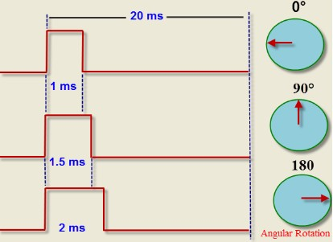

Figure : Controlling a servo motor with angle rotations.

POSITIONAL ROTATION SERVO MOTOR

  - Positional rotation servo motor is a most common type of servo motor.

  - These common servos involve in radio controlled water, radio controlled cars, aircraft, robots, toys and many other applications.

CONTINUOUS ROTATION SERVO MOTOR
  - Continuous rotation servo motor is quite related to the common positional rotation servo motor, but it can go in any direction indefinitely.
  - This type of motor is used in a radar dish if you are riding one on a robot or you can use one as a drive motor on a mobile robot.

ADVANTAGES OF SERVO MOTOR

  - The servo motor is small and efficient.

  - High-speed operation is possible by the servo motors.

APPLICATIONS OF SERVO MOTOR

  - The applications of servo motors mainly involve in computers, robotics, toys, CD/DVD players, etc.

DC SERVO MOTOR INTERFACING WITH THE MICRO CONTROLLER

  - The actual position of the motor is sensed with the sensor and it is compared with the desired position.

  - The difference between the actual and desired position, the motor rotates either in clockwise direction or anticlockwise direction.
  - Thus the position of the rotor is controlled by the controller output.

FLOWCHART:

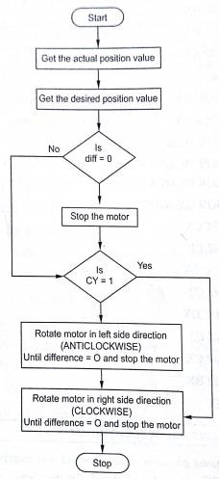

Figure : Flow chart for closed loop control of DC servo motor

DC SERVO MOTOR INTERFACING WITH 8051.

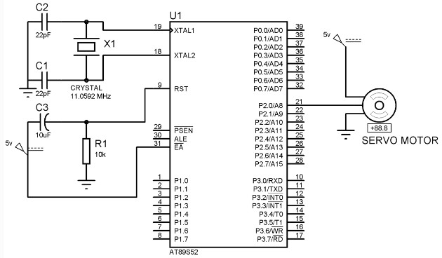
Figure: DC Servo Motor Interfacing With 8051

PROGRAM:

Label | Mnemonics | Operand | Comments
 | MOV | A, P0 | Get the actual position value from the  input port P0.
 | MOV | R0  , #data | Get the desired position value in R0 of  selected register bank.
 | SUBB | A, R0 | Find the difference between actual and  desired position.
 | MOV | R1, A | Store the result in R1 of selected  register bank.
 | JZ | L1 | If the result is zero, make the motor to  stop.
 | JC | RIGHT | If the magnitude of desired position is  high, go to RIGHT.
LEFT: | RLC | A
 | DNZ | R1, LEFT | Or else make the motor to rotate left  until the desired position is reached.
L1: | MOV | P1, 00H | Make the rotor to stop rotating.
RIGHT: | RRC |  | A make the motor to rotate right until  the desired position is reached.
 | DNZ | R1, RIGHT
 | SJMP | L1 | Make the rotor to stop rotating
 | RET

SAMPLE PROGRAMS: (8051 Microcontroller)
- Add two 8-bit numbers

MOV A, #30H ; (A)  30
ADD A, #50H ; (A) → (A) + 50H

Add two 16- bit numbers

MOV DPTR, #2040H; (DPTR)   ← 2040H (16 bit number)
MOV A, #2BH ;(A) 2BH (lower byte of second 16 bit number)
MOV B, #20H ; (B)  20H (Higher byte of second 16 bit number)
ADD A, DPL ; Add lower bytes
MOV DPL, A ; Save result of lower byte addition
MOV A, B ; Get higher byte of second number in A
ADD A, DPH ; Add higher bytes with any carry from lower byte addition
MOV DPH, A ; Save result of higher byte addition

Division two 8-bit numbers

MOV A, #90 ; Get the first number in A MOV B, #20 ; Get the second number in B
DIV A, B ; A+B, Remainder in B and Quotient in A

To find the sum of 10 numbers stored in the array. (June 2016)

Statement: Calculate the sum of series of numbers. The length of the series is in memory location 2200H and the series itself begins from memory location 2201H.

- Assumes the sum to be 8-bit number so you can ignore carries. Store the sum at memory location 2300H.
- Assume the sum to be 16-bit number. Store the sum at memory locations 2300H and 2301H.

Sample program

2200H = 04H
2201H = 20H
2202H = 15H
2203H = 13H
2204H = 22H
Result = 20+15+13+22=6AH 2300H=6AH

Program

MOV DPTR, #2200H ; Initialize memory pointer MOVX A, @DPTR ; Get the count
MOV R0, A ; Initialize the iteration counter
INC DPTR ; Initialize pointer to array of numbers
MOV R1, #00 ; Result = 0
BACK: MOVX A, @DPTR ; get the umber
ADD A, R1 ; A← Result + A
MOV R1, A ; Result ← A
INC DPTR ; Increment the array pointer
DJNZ R0, BACK ; Decrement iteration count if not zero repeat
MOV DPRT, #2300H ; Initialize memory pointer
MOV A, R1 ; Get the result
MOVX @DPTR, A ; Store the result

Sample program

2200H = 04H
2201H = 9AH
2202H = 52H
2203H = 89H
2204H = 3EH
Result = 9AH + 52H + 89H + 3EH = 6AH
2300H=B3H Lower byte
2301H = 01H Higher byte

Program

MOV DPTR, # 2200H ; Initialize memory pointer MOVX A, @DPTR ; Get the count
MOV R0, A ; Initialize the iteration counter
INC DPTR ; Initialize pointer to array of numbers
MOV R2, #00 ; [Make result R2= 00H]
MOV R1, #00 ; [Make result R1= 00H]
BACK: MOVX A, @DPTR ; get the number
ADD A, R1 ; A← Result + A
MOV R1, A ; Result ← A
ADDC R2, #00 ; if carry exists, add it to MSD INC DPTR ; Increment the array pointer
DJNZ R0, BACK ; Decrement iteration count if not zero repeat
MOV DPTR, #2300H ; Initialize memory pointer
MOV A, R1 ; Get the lower byte of result
MOVX @DPTR, A ; Store the lower byte of result
INC DPTR ; Increment memory pointer
MOV A, R2 ; Get the higher byte of result
MOVX @DPTR, A ; Store the higher byte of result

************************************************************************************
Design a microcontroller based water level control system in detail. (April 2018)
************************************************************************************

Water Level Controller using 8051 Circuit Principle
- This system mainly works on a principle that “water conducts electricity”. The four wires which are dipped into the tank will indicate the different water levels. Based on the outputs of these wires, microcontroller displays water level on LCD as well as controls the motor.
- Initially when the tank is empty, LCD will display the message LOW and motor runs automatically. When water level reaches to half level, now LCD displays HALF and still motor runs.
- When the tank is full, LCD displays FULL and motor automatically stops. Again, the motor runs when water level in the tank becomes LOW.
- The water level probes are connected to the P0.0, P0.1 and P0.2 through the transistors (they are connected to the base of the transistors through corresponding current limiting resistors). P0.0 for LOW level, P0.1 for HALF Level and P0.2 for HIGH Level.
- The Collector terminals of the Transistors are connected to VCC and the Emitter terminals are connected to PORT0 terminals (P0.0, P0.1 and P0.2).
- PORT1 of the microcontroller is connected to the data pins of LCD and the control pins RS, RW and EN of the LCD Display are connected to the P3.6,
- GND and P3.7 respectively.

Algorithm for Water Level Controller Circuit
- First configure the controller pins P0.0, P0.1 and P0.2 as inputs and P0.7 as output.
- Now, initialize the LCD.
- Continuously check the water level input pins P0.0, P0.1 and P0.2.
- If all the pins are low, then display tank as “EMPTY” on the LCD and make P0.7 pin HIGH to run the motor automatically.

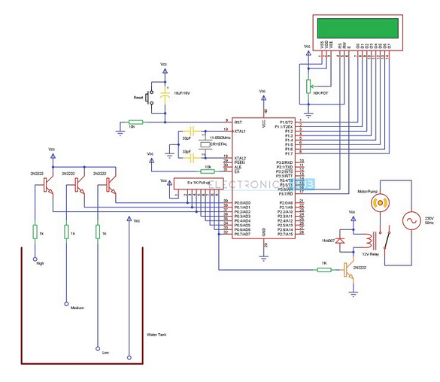

Figure: Water Level Controller using 8051
- If the level is low i.e. if P0.0 is HIGH, display the water level as “LOW” and continue to run the motor.
- A HIGH pulse on the pin P0.1 indicates that water has reached half level. So, display the same thing on LCD and run the motor normally.
- If P0.2 is HIGH, then the water level in the tank is FULL.
- Now, make the P0.7 pin as LOW to turn off the motor automatically
*****************************************************************************************Develop a 8051 ALP to evaluate an arithmetic expression (A–B) XC Where A,B,C are8 bit data in internal memory.Assme A>B and store the result in external memory.Explain the program developed.( Dec 2018)
MOV A,#DATA1
MOV B,DATA2
MOV C,#DATA3
SUBB A,B
JC L1
MOV B,C
MUL AB
LI MOV DPTR,#4500
MOV @DPTR,A
L2 SJMP L2

